EMERGING METHODS FOR EARLY DETECTION OF FOREST FIRE

MODEL BUILDING SAVE THE MODEL

|  |  |
| --- | --- |
| Team ID | PNT2022TMID34010 |
| Project Name | Project- Emerging Methods For Early Detection of Forest Fire |

**SAVE THE MODEL**

Your model is to be saved for future purposes. This saved model also is integrated with an android application or web application in order to predict something.

**IMPORT LIBRARIES:**

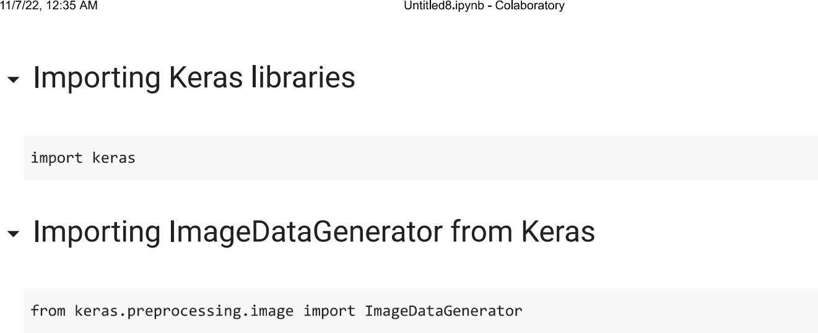

**IMPORT ImageDataGenerator FROM KERAS:**

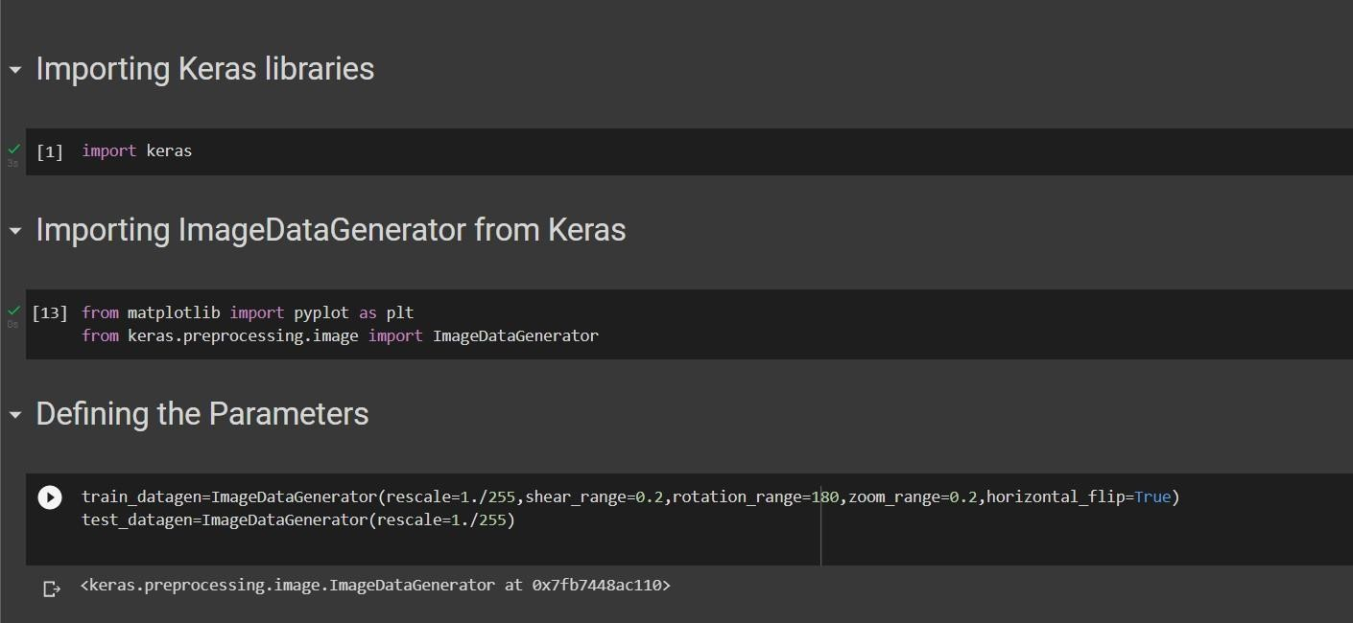

APPLYING ImageDataGenerator to train dataset:

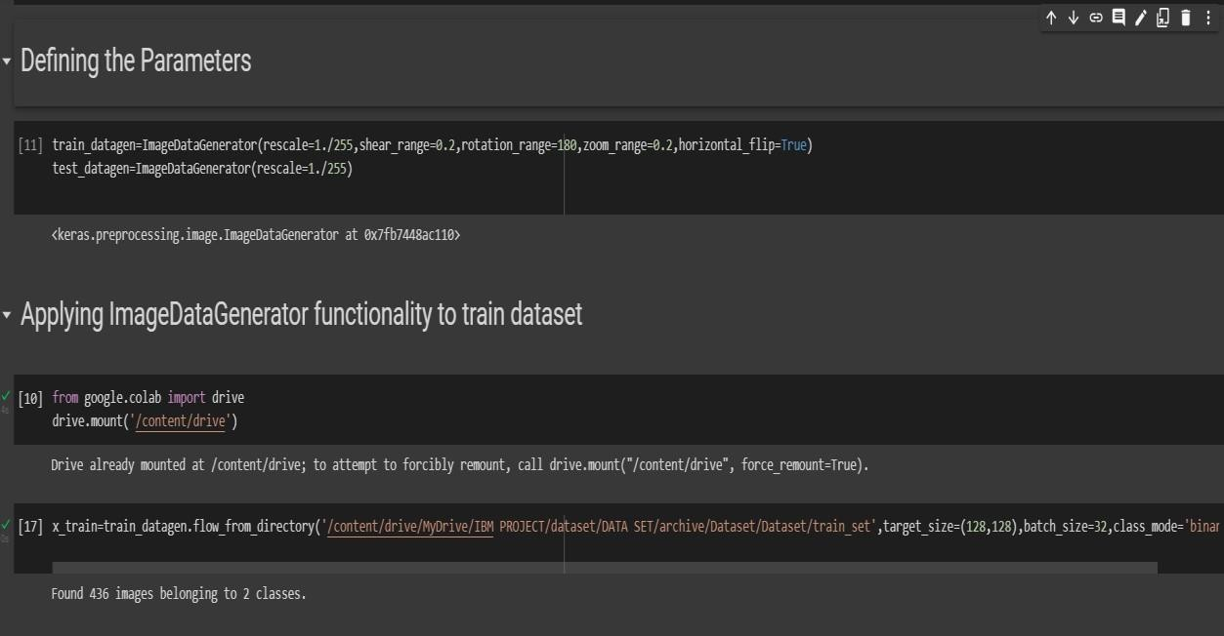ply**flow_from_directory ( )**methodfor Train folder.

APPLYING ImageDataGenerator to test dataset:

Applying the **flow_from_directory ( )** methodfortest folder.

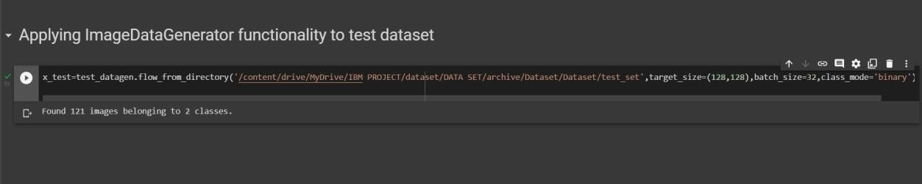

IMPORTING MODEL BUILDING LIBRARIES:

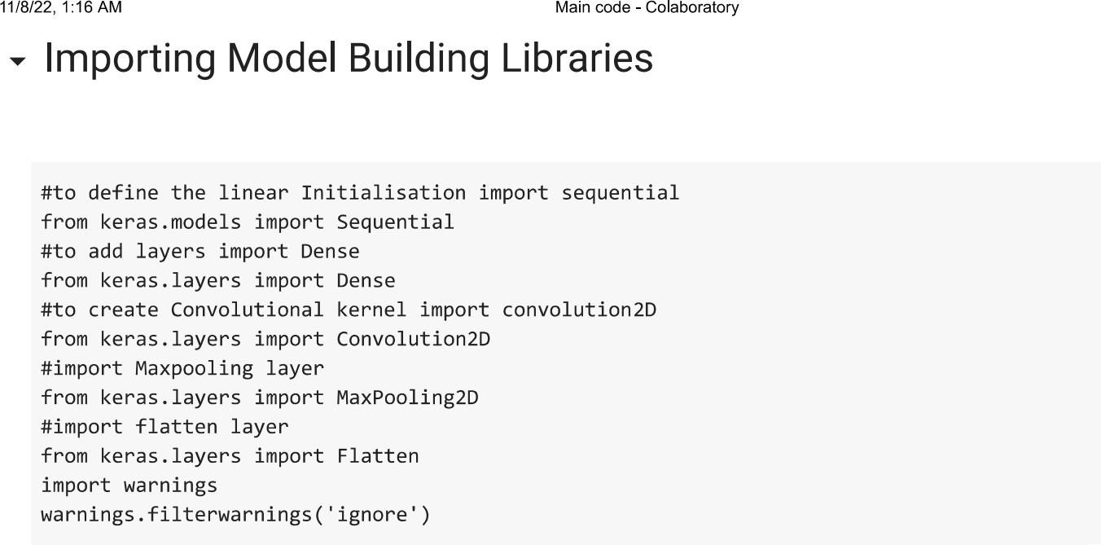

**INITIALIZING THE MODEL:**

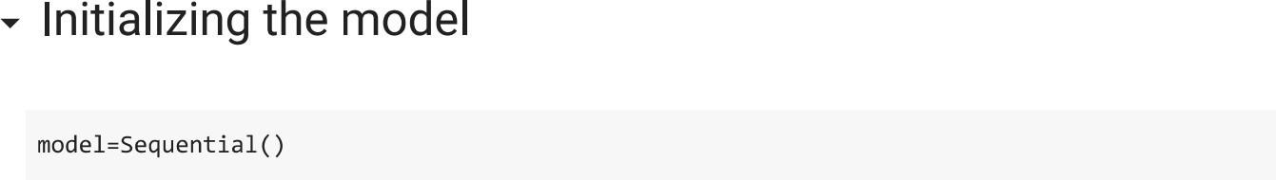

**ADDING CNN LAYERS:**

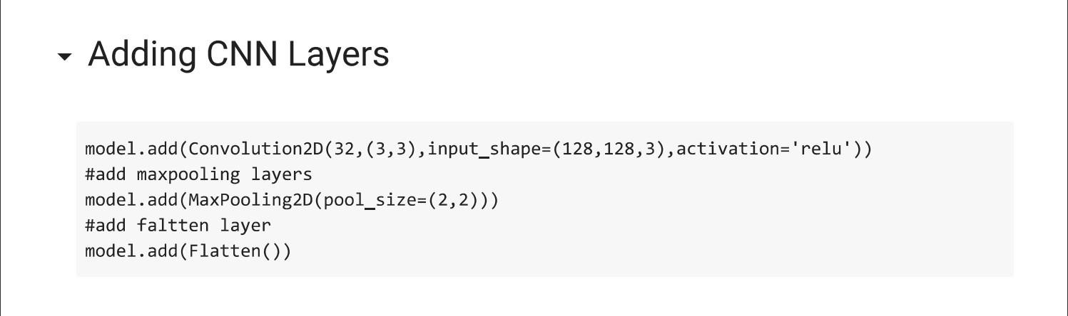

**ADDING DENSE LAYERS:**

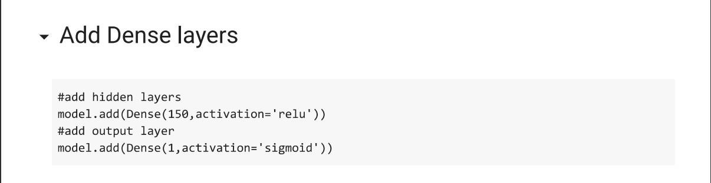

**CONFIGURING THE LEARNING PROCESS:**

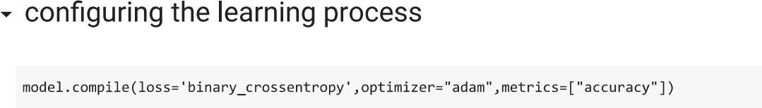

**TRAINING THE MODEL:**

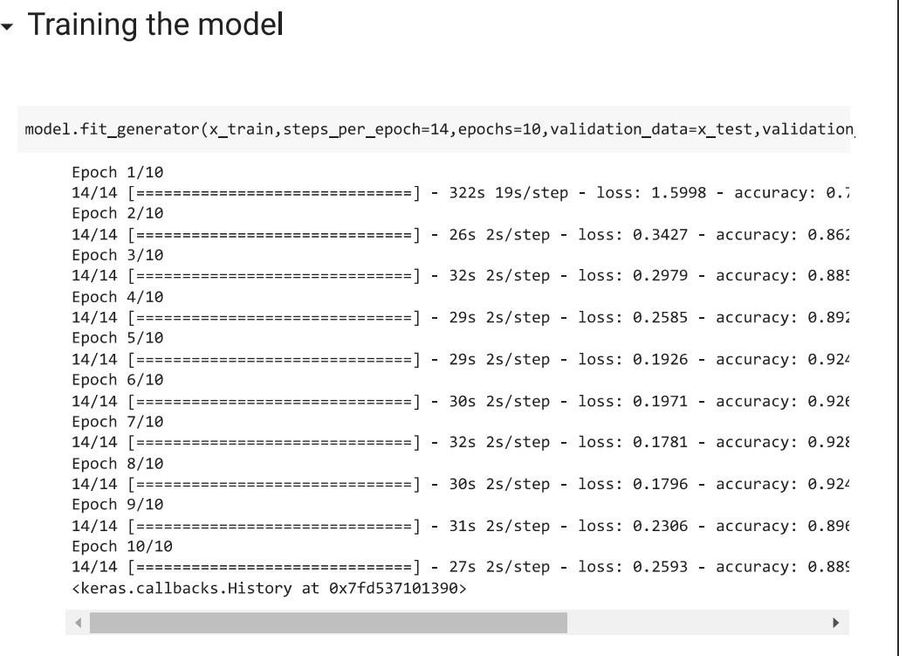

**SAVE THE MODEL:**

